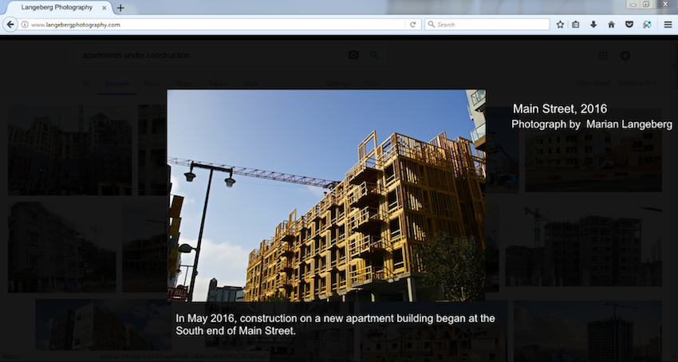

**Source is fictional**

In May 2016, construction on a new apartment building began at the south end of Main Street.